Gap Analysis:
Assessment and Care of Adults at Risk for Suicidal Ideation and Behaviour, January 2009
Work Sheet

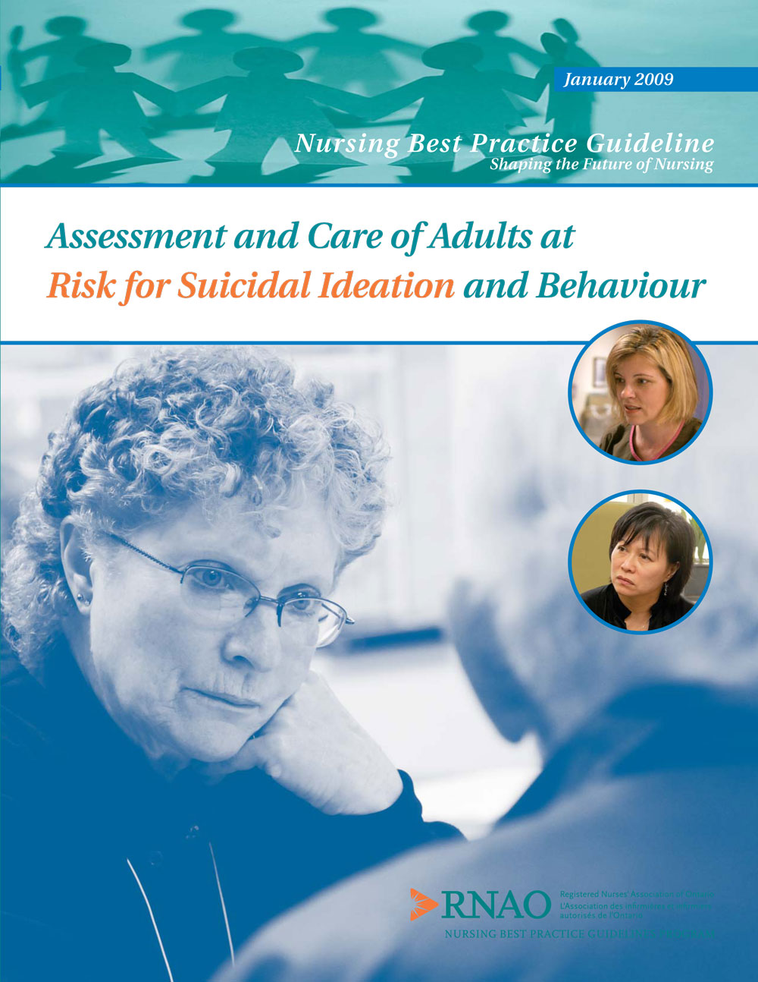

This guideline can be downloaded for free at:
http://rnao.ca/bpg/guidelines/assessment-and-care-adults-risk-suicidal-ideation-and-behaviour

The RNAO Leading Change Toolkit 3rd Edition
https://rnao.ca/leading-change-toolkit

Date Completed:
Team Members participating in the Gap Analysis:

Completion of this gap analysis allows for the annual comparison of your current practice to evidence-based practices as regulated by the MOHLTC per Fixing Long-Term Care Act, 2021 at https://www.ontario.ca/laws/statute/21f39 &
O. Reg. 246/22: GENERAL (ontario.ca)
RNAO Best Practice Guideline Recommendations | Met | Partially Met | Unmet | Notes  (Examples of what to include: is this a priority to our home, information on current practice, possible overlap with other programs or partners)
Practice Recommendations
1. The nurse will take seriously all statements made by the client that indicate, directly or indirectly, a wish to die by suicide, and/or all available information that indicates a risk for suicide.
(Level of Evidence = III)
2. The nurse works toward establishing a therapeutic relationship with clients at risk for suicidal ideation and behaviour.
(Level of Evidence = IV)
3. The nurse works with the client to minimize the feelings of shame, guilt and stigma that may be associated with suicidality, mental illness and addictions.
(Level of Evidence = III)
4. The nurse provides care in keeping with the principles of cultural safety/cultural competence.
(Level of Evidence = III)
5. The nurse assesses and manages factors that may impact the physical safety of both the client and the interdisciplinary team.
(Level of Evidence = IV)
6. a) The nurse recognizes key indicators that put an individual at risk for suicidal behaviour, even in the absence of expressed suicidality. For individuals who exhibit risk indicators, the nurse conducts and documents an assessment of suicidal ideation and plan.
(Level of Evidence = IV)
6. b) The nurse assesses for protective factors associated with suicide prevention.
(Level of Evidence = IV)
6. c) The nurse obtains collateral information from all available sources: family, friends, community supports, medical records and mental health professionals.
(Level of Evidence = IV)
7. The nurse mobilizes resources based upon the client’s assessed level of suicide risk and associated needs.
(Level of Evidence = IV)
8. The nurse ensures that observation and therapeutic engagement reflects the client’s changing suicide risk.
(Level of Evidence = IV)
9. The nurse works collaboratively with the client to understand his/her perspective and meet his/her needs.
(Level of Evidence = IV)
10. The nurse uses a mutual (client nurse) problem-solving approach to facilitate the client’s understanding of how they perceive his/her own problems and generate solutions.
(Level of Evidence = IV)
11. The nurse fosters hope with the suicidal client. (Level of Evidence = IV)
12. The nurse is aware of current treatments to provide advocacy, referral, monitoring and health teaching interventions, as appropriate.
(Level of Evidence = IV)
13. a) The nurse identifies persons affected by suicide that may benefit from resources and supports, and refers as required.
(Level of Evidence = IV)
13. b) The nurse may initiate and participate in a debriefing process with other health care team members as per organizational protocol.
(Level of Evidence = IV)
14. The nurse seeks support through clinical supervision when working with adults at risk for suicidal ideation and behaviour to become aware of the emotional impact to the nurse and enhance clinical practice.
(Level of Evidence = IV)
Educational Recommendations
15. Nurses who work with individuals at risk for suicide must have the appropriate knowledge and skills acquired through basic nursing education curriculum, ongoing professional development opportunities and orientation to new work places. (Level of Evidence = IV)
16. Nursing curricula should incorporate content on mental health issues, including suicide risk reduction and prevention, in a systematic manner to promote core competencies in mental health practice.
(Level of Evidence = IV)
Organization and Policy Recommendations
17. Health care organizations that admit suicidal clients must provide a safe physical environment that minimizes access to means for self-injurious behaviour.
(Level of Evidence = IV)
18. In health care organizations that admit suicidal patients, nursing staff complements should be appropriate to the patient: nurse ratio and to staff mix (i.e. RN, RPN, health care aide) to safely meet the unpredictable needs of acutely suicidal patients.
(Level of Evidence = IV)
19. Organizations ensure that critical incidents involving suicide are reviewed systematically to identify opportunities for learning at all levels of service delivery.
(Level of Evidence = IV)
20. Organizations develop policies and structures related to peer debriefing following a critical incident, such as a death by suicide. Policies should be developed to support staff and minimize vicarious trauma.
(Level of Evidence = IV)
21. Organizations allocate resources to ensure that all nurses have opportunities for clinical supervision and coaching on an ongoing basis.
(Level of Evidence = IV)
22. Organizations implement policies regarding the systematic documentation of suicide risk assessments.
(Level of Evidence = IV)
23. Organizations promote the services available within the organization and community that may support the care of adults at risk for suicidal ideation and behaviour.
(Level of Evidence = IV)
24. Organizations support nurses’ opportunities for professional development in mental health nursing. (Level of Evidence = IV)
25. Organizations support research initiatives related to suicide and other mental health issues.
(Level of Evidence = IV)
26. Organizations develop a plan for the implementation of best practice guideline recommendations that include:
- An assessment of organizational readiness and barriers to education.
- Involvement of all members (whether in a direct or indirect supportive function) who will contribute to the implementation process.
- Ongoing opportunities for discussion and education to reinforce the importance of best practices.
- Dedication of a qualified individual to provide the facilitation required for the education and implementation process.
- Opportunities for reflection on personal and organizational experience in implementing guidelines.
- Strategies for sustainability.
- Allocation of adequate resources for implementation and sustainability, including organizational and administrative support.
(Level of Evidence = IV)

